Karthik Pradeep Hegadi

**2KE20CS032**

**Assignment 5**

*Understood. To follow the provided instructions and create the files/directory using the same name and case as provided in the task steps, please provide me with the specific names and case instructions for the files/directory you want to create.*

**Previously I have installed and took screen sorts.**

**Package management**

1. Install Apache server (httpd) using yum

sudo yum install httpd

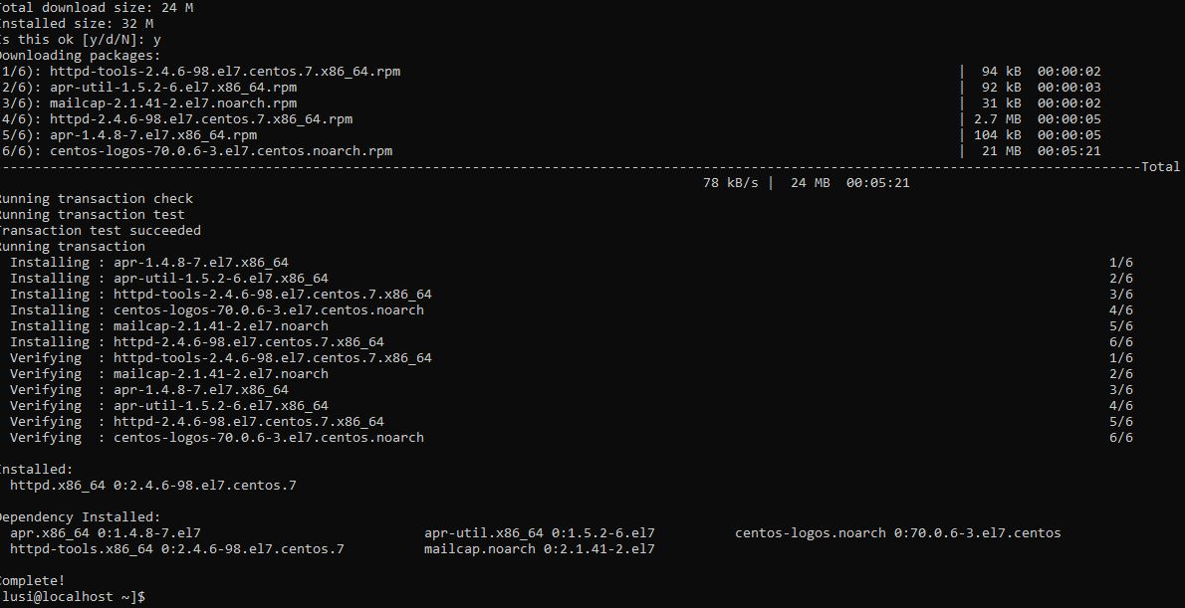

2. Install Python version above 3 using zip/tgz source code installation:

I have downloaded development tool for zip/tgz

Using command sudo yum group install "Development Tools"

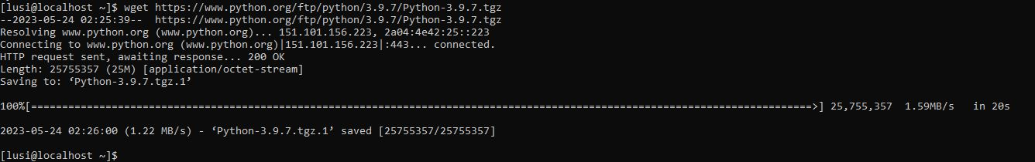**

Extract python

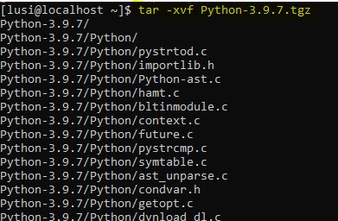

Cd python and config the settings

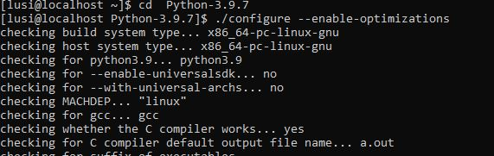

Make command to install exe file

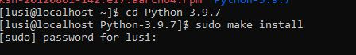

3.Display the python 3 version using command



4.Install any software using rpm

Downloard the package sing wget command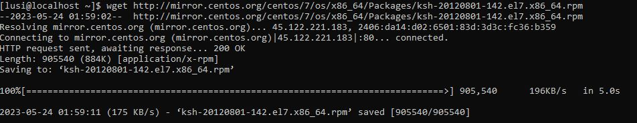

Install using rpm command 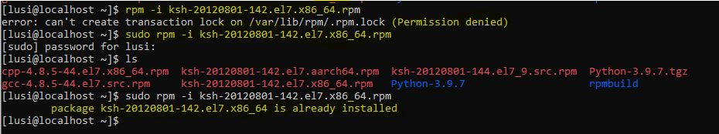 5.Uninstall Apache server



6.Uninstall the software which is installed in step4 using “rpm-e” command

Install



verification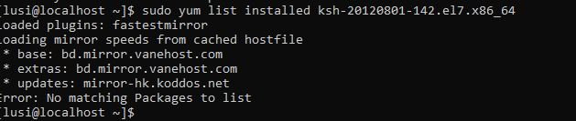

7.Write the command to list all the packages installed using yum